National University of Computer and Emerging Sciences



Lab Manual 04

Object Oriented Programming

Course Instructor | Ms. Tayba Bukhari
Lab Instructor (s) | Ms. Samman Ashraf Ms. Syeda Zehra Batool
Section | BCS-2B
Semester | Summer 2023

Department of Computer Science FAST-NU, Lahore, Pakistan

Objectives
After performing this lab, students will practice:

- Classes, Contructors, Destructors
- Dynamic arrays in classes

TASK-1:
You are developing a program to manage a student database. Create a C++ class that uses a dynamic 1D array to store the student IDs. The “Student” class should have the following features:
- Data Members
- Pointer to the dynamic array representing student IDs.
- Number of students in the database.

- A constructor that takes the number of students and dynamically allocates memory for the ID array.
- Constructs the StudentDatabase object with the specified number of students and dynamically allocates memory for the studentIDs array.
- Write an overloaded/parameterized Constructor of Student class that initializes the data members of student class with the received parameters and prints “Overloaded/parameterized Constructor Called”
- Destructor:
- ~StudentDatabase(): Releases the dynamically allocated memory for the studentIDs array.
- Getter and Setter:
- Sets the ID for a specific student.
- Returns the ID for a specific student.
- Functions to input the IDs, search for a specific ID, and remove a student from the database.

Note: Implement error handling for duplicate IDs, invalid searches, and memory allocation failures.

TASK-2:
You are building a program to track the sales of a store. Design a C++ class “SalesTrack” that uses a dynamic 1D array to store the daily sales for a month. Include the following functionalities:

- Data Members
- A constructor that takes the number of days in the month and dynamically allocates memory for the sales array and Parameterized Constructor.
- Destructor & Getters and Setters
- Functions to input the sales for each day, calculate the total sales for the month, and find the average daily sales.
Note: Implement error handling for invalid inputs.

TASK-3:
Design a class Matrix which contains following data members:
- A pointer to a 2D integer array
- An integer variable to store the dimension of matrix (Your matrix will have equal number of rows and columns)

Your class should have following functions:
- Getters/setters: To get and set the data members
- Default Constructor: Initialize the values of rows and columns to zero and assign Null to pointer variable
- void InputMatrix(int dimension): It takes input the values from user(console) and save the values in 2D matrix (declared in class).
Note: You have to take dimension of matrix as input from user in main function and then pass it to InputMatrix function
- void DisplayMatrix(): Displays the matrix in proper format.
- rotateOuterLayerBy1(): It should rotate the outermost layer of matrix by one place, anti-clockwise. Your code cannot create an extra array to accomplish the given task. But you can create one or two extra integers.
- void DeallocateMemory: Deallocates all the memory.
Note: Handle the cases where matrix multiplication is not possible and provide appropriate error messages.

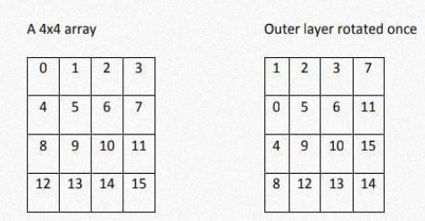
Example:

***************************************************

